Ai lab Task 5(2)

Written work screenshot:

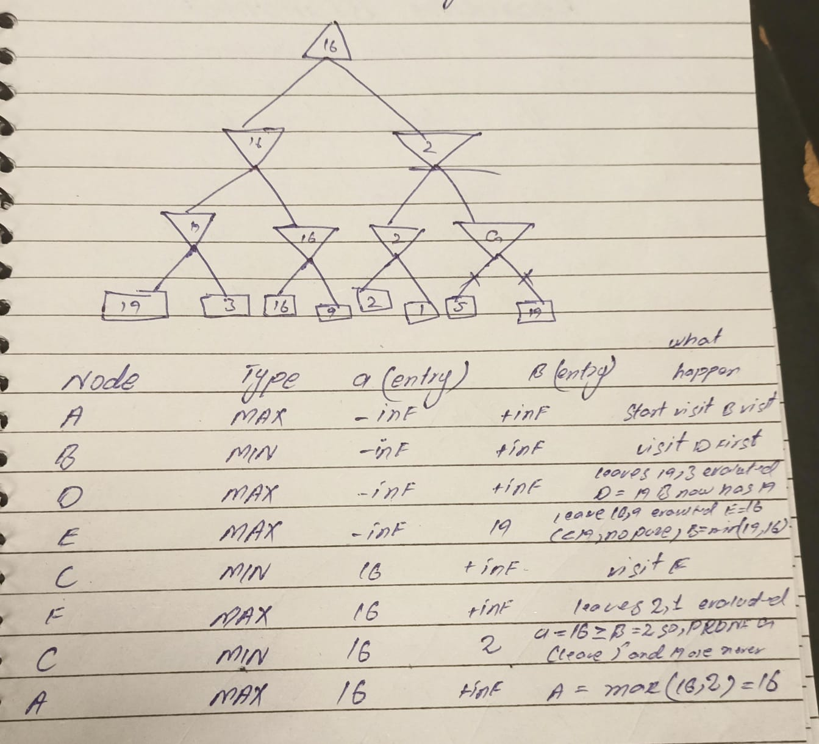

Task output screenshot:

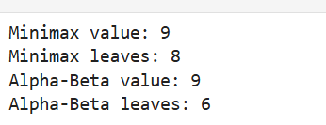

Learning Outcome:
Alpha-Beta pruning reduces the amount of search required while preserving the optimal Minimax value of 9 for the same game tree and branch ordering.

